Adding Card Interface

# What and why?

There may be times when you wish to provide students with links to Blackboard resources or activities. One way to do this is to [use indirect links to Blackboard content items](https://djplaner.github.io/Content-Interface-Tweak/creating/blackboardContent/#indirect-link-to-content-item-blackboard-content-link). While such links can be safely copied from one offering to another, they offer no other functionality and are not visually appealing.

Another way to do this is via [the Card Interface](https://djplaner.github.io/Card-Interface-Tweak/). It provides a way to indirectly link to Blackboard content items that can also be safely copied from one offering to another. It also provides additional functionality, including:

* A more [visually appealing, contemporary interface](https://www.justinmind.com/blog/cards-ui-design/) appropriate for computers and mobile devices.
* [Grouping and numbering links](https://djplaner.github.io/Card-Interface-Tweak/customiseACard/#changing-the-card-label) (cards).
* [Embedding videos](https://djplaner.github.io/Card-Interface-Tweak/customiseACard/#use-a-video-powerpoint-presentation-etc-instead) and other live content.
* [Display dates](https://djplaner.github.io/Card-Interface-Tweak/customiseACard/#adding-a-date-or-date-range), including dates based on the university trimester calendar.
* [Working with the Blackboard *Review Status*](https://djplaner.github.io/Card-Interface-Tweak/customiseACard/#enabling-review-status) functionality.
* A [“coming soon” ability](https://djplaner.github.io/Card-Interface-Tweak/customiseACard/#making-a-coming-soon-card).

### A concrete example

Assume you have a single assessment item that covers five different quizzes to be completed by the students. You use the Content Interface to provide information about this assessment item, including links to the five individual Blackboard quizzes the students will complete.

There are two ways you can provide these links. You can use links or cards. Figure 1 and Figure 2 provide a concrete example of the two approaches.

## Using links

Figure 1 is one way to implement this example using [*Blackboard Content Links*](https://djplaner.github.io/Content-Interface-Tweak/creating/blackboardContent/#indirect-link-to-content-item-blackboard-content-link). The *Quiz availability* column contains *Blackboard Content Links* to each of four quizzes. The link destinations for these four links are content items on this Blackboard page (the Content Interface hides them from students when *Edit Mode* is off). The link destination matches the name of the item (i.e. *Quiz 1*; *Quiz 2*; *Quiz 3*; *Quiz 4*).

An item may not be available to students because it has not been added to the page, or because adaptive release has been applied. An unavailable item will be displayed as **(not currently available**) e.g. *Quiz 4* in Figure 1.

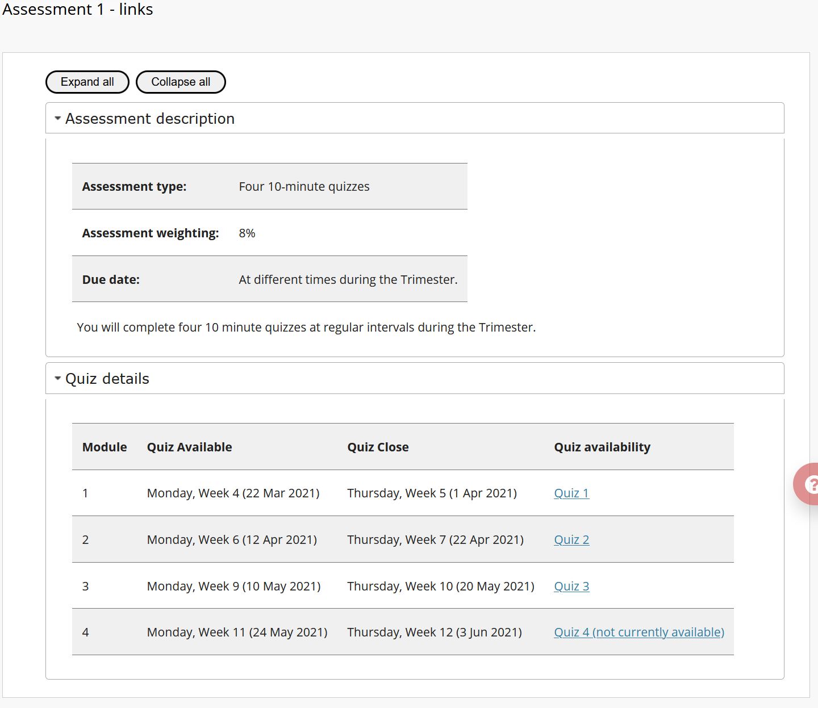

Figure 1 - Using Blackboard Content Links to display four Blackboard quizzes

## Using Cards

Figure 2 is using cards to display information about and links to the same four quizzes, including show off some of the additional card functionality.

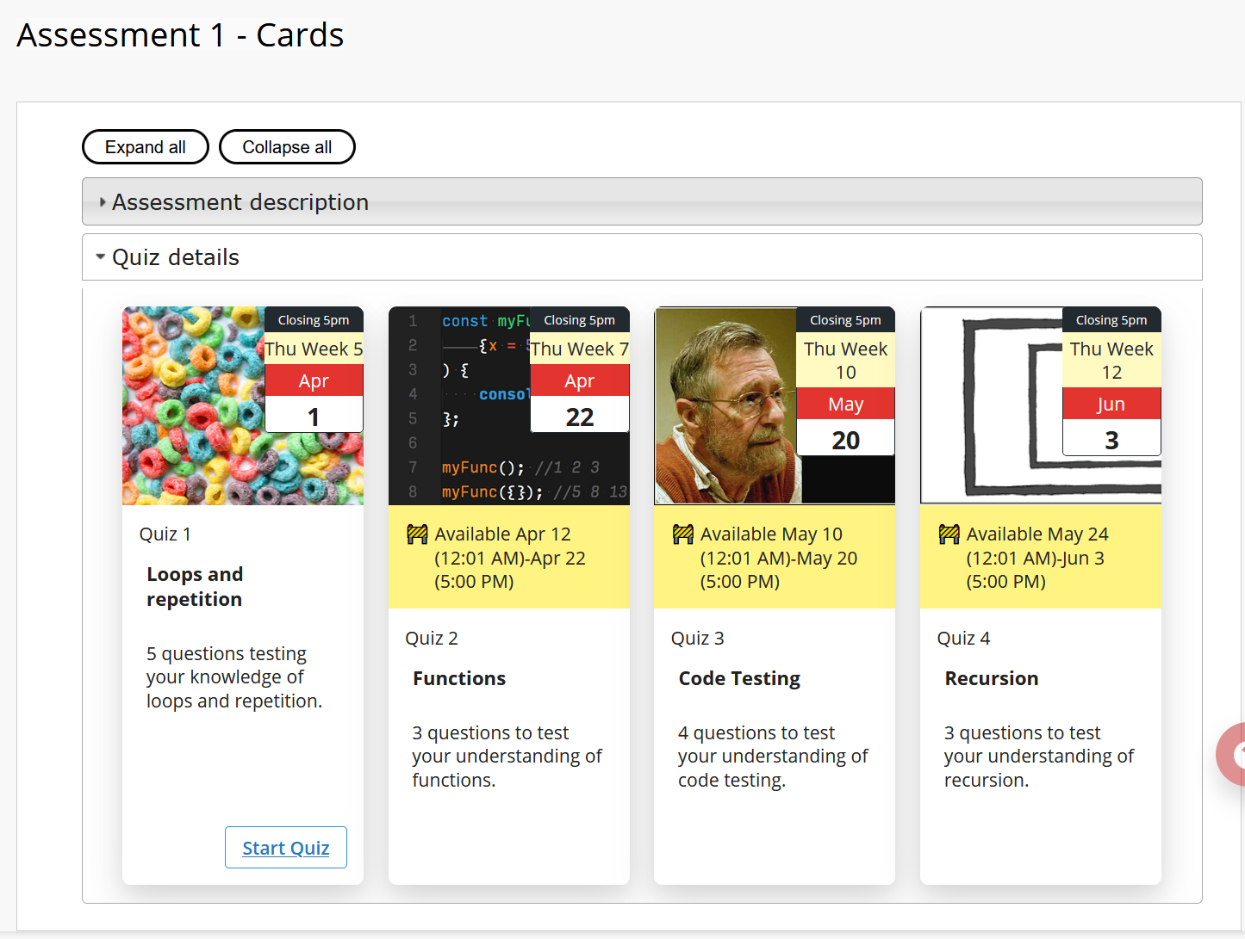

Figure 2 - Displaying details and links about four Blackboard quizzes using cards

# How to add cards to the Content Interface

The following assumes you have [set up the Content Interface](https://djplaner.github.io/Content-Interface-Tweak/using/setup/) on a Blackboard content area.

There are four (one optional) steps to add cards to the Content Interface:

1. Add the card Content Items to the content area.
2. Configure the card interface (optional).
3. Add the cards to the Content Word document.
4. Update the Blackboard content area.

Each is explained in the following sections using the example of translating Figure 1 (links) into Figure 2 (cards).

## Add the “card” Content Item(s)

Each “card” is a visual representation of a Blackboard content item on the same Blackboard content area (page) as the Content Interface. A “card” Blackboard content item must be [customised with at least one “card meta data variable”](https://djplaner.github.io/Card-Interface-Tweak/customiseACard/). Each variable controls the display and form of [a card component](https://djplaner.github.io/Card-Interface-Tweak/customiseACard/#the-components-of-a-card).

### Example

Figure 3 shows part of the Blackboard content area from Figure 1, but with *Edit Mode* on. This displays the four content items for the four quizzes. This example is working with this page where the content items already exists. In this case, no need to add these items. All that is required to add card meta data to the existing items to indicate that they should be displayed as cards and how they will be displayed.

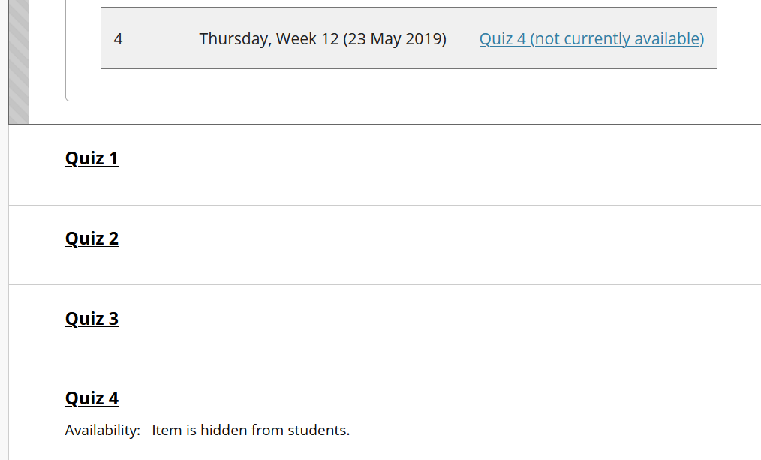

Figure 3 - "Normal" Blackboard content items before being customised as cards

Figure 4 shows how the first of the content items (Quiz 1) from Figure 2 has been customised to achieve that cards displayed in Figure 2. The following table summarises the changes and their impact. The included links are to the more detail documentation for the Card Interface associated with the specific change.

|  |  |
| --- | --- |
| **Change** | **Impact** |
| Change content item name (Quiz 1 to Quiz 1: Loops and repetition) | Provides a more meaningful card name and work better with the card label |
| [*Card Image*](https://djplaner.github.io/Card-Interface-Tweak/customiseACard/#adding-an-image) | Is required to identify the item as a card. Specifies the URL for the image to be displayed for the card. |
| [*Card Date*](https://djplaner.github.io/Card-Interface-Tweak/customiseACard/#adding-a-date-or-date-range) | Specify the card’s date element as the Thursday of Week 5 of this course site’s Griffith University study period. i.e. the date the quiz will close. |
| *Card Date Label* | Change the date label from the default (*Commencing*) to *Closing 5pm* |
| [*Card Label*](https://djplaner.github.io/Card-Interface-Tweak/customiseACard/#changing-the-card-label) | Change the card label from the default (*Module*) to *Quiz*. |
| [*Card Coming Soon*](https://djplaner.github.io/Card-Interface-Tweak/customiseACard/#making-a-coming-soon-card) | Indicate that the card should remind students that it is only available for use from Monday (12:01pm) of Week 4 through to 5pm on Thursday of Week 5. The week’s apply to the course site’s Griffith University study period. |

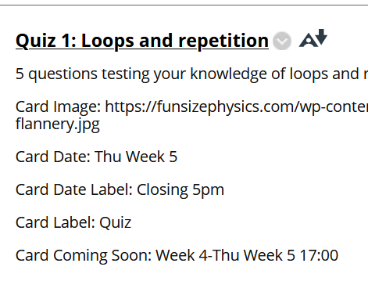

Figure 4 - First content item from Figure 3 customised by adding card meta data

## Configure the Card Interface

Customising individual content items customises how individual cards are displayed. However, there are instances where you wish to [customise how the Card Interface](https://djplaner.github.io/Card-Interface-Tweak/customiseAllCards/) (i.e. all the cards) are displayed.

For example, Figure 5 shows the default view of the cards once they’ve all been configured as in Figure 4. At least, when they are being viewed on March 25. Since it is March 25 the first quiz is available for students. The remining quizzes are not.

By default, the cards are shown three to a row. This is not what is shown in Figure 2 where there are four cards per row.

To make this change we need to customise the Card Interface. This is done by:

1. Adding to the Blackboard content area an empty content item named *Card Interface*.
2. Customising that content item using [card templates and attributes](https://djplaner.github.io/Card-Interface-Tweak/customiseAllCards/#how-to-customise-templates-and-attributes).

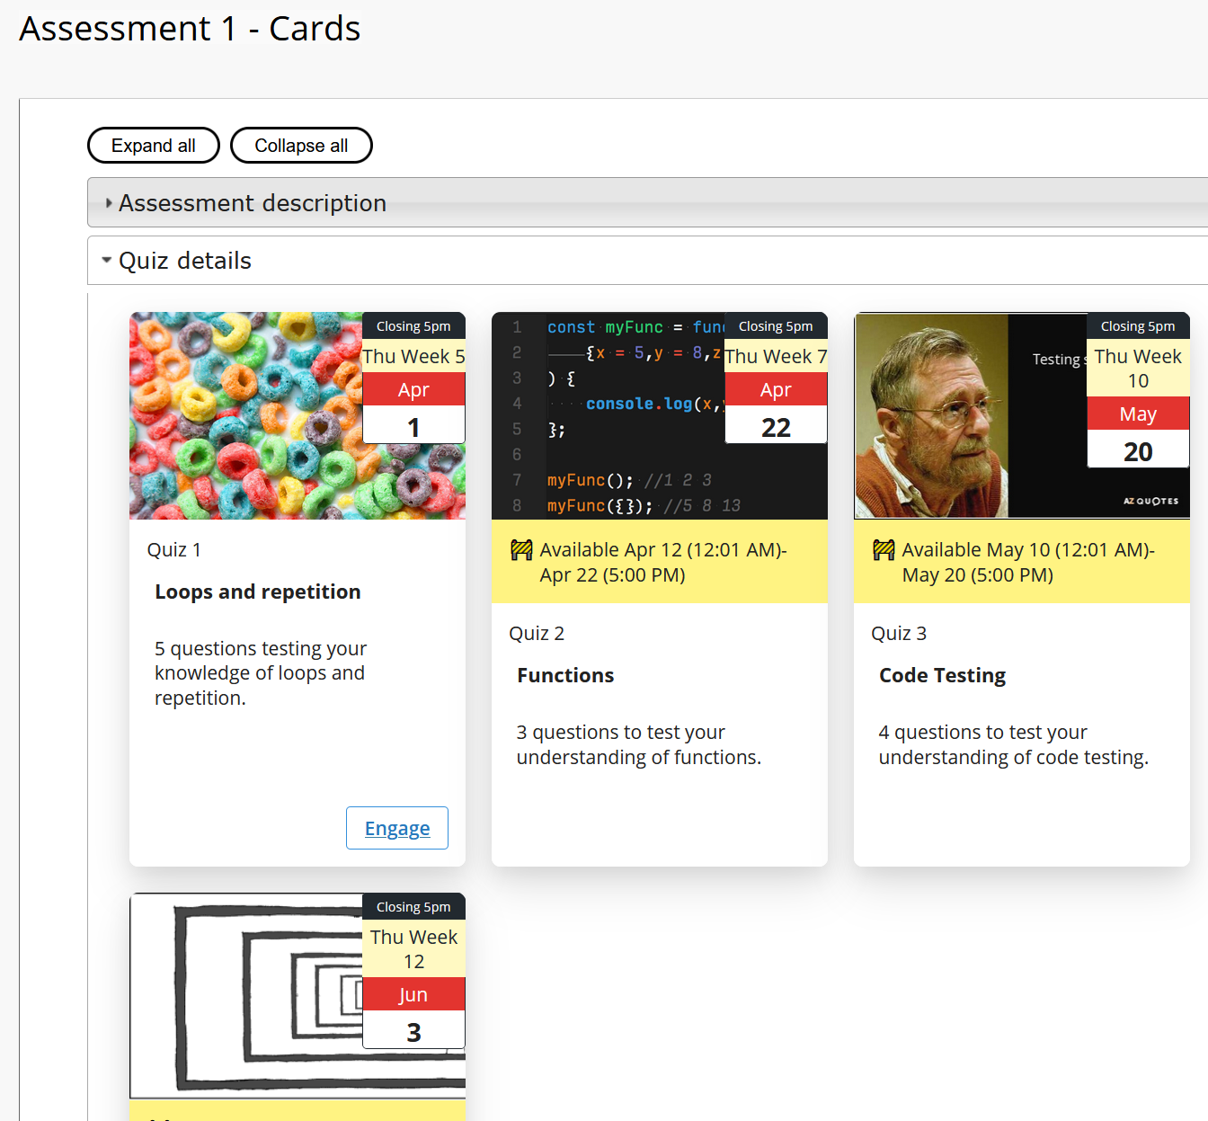

Figure 5 - Default quiz cards

### Example

Figure 6 shows the creation of the *Card Interface* content item for our example. It is using two attributes described in the following table. Compare Figure 5 (the default configuration) with Figure 2 (with this configuration).

|  |  |
| --- | --- |
| **Attribute** | **Purpose** |
| engage=”Start Quiz” | [Change the “Engage” button label](https://djplaner.github.io/Card-Interface-Tweak/customiseAllCards/#how-to-change-or-remove-the-engage-button) on each card to “Start Quiz” |
| by4 | Show four cards per row, rather than the default 3 |

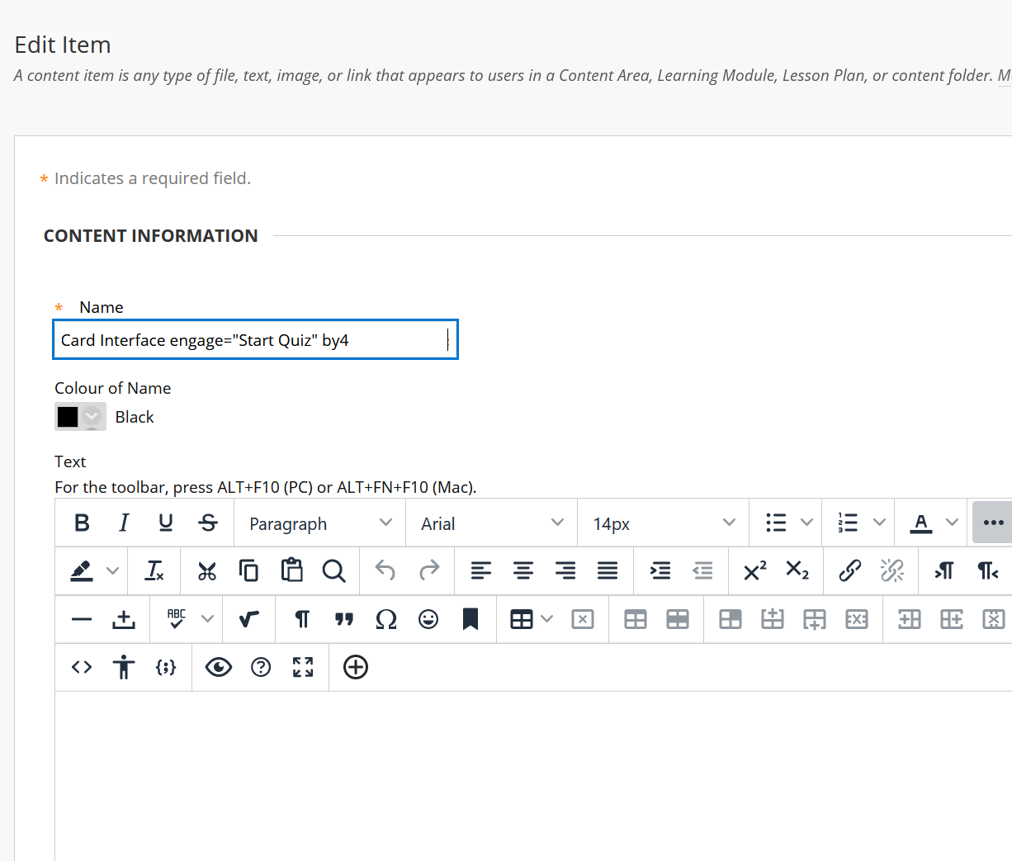

Figure 6 - Configuring the card interface using templates and attributes

## Add the cards to the Content Word document

The cards you wish to display can occur anywhere in the Content Interface. To specify where the cards appear, you create a list of *Blackboard Card* names. i.e. a list of names that match the names of the content items you wish to link to.This is done by applying the *Blackboard Card* style in the Word document.

### Example

Figure 7 shows the Word document used to create the content interface shown in Figure 2 and Figure 5. The four item list under the heading *Quiz Details* has had the *Blackboard Card* style applied to it. Each of the items contain text that **exactly** matches the names given to the Blackboard content items for the quizzes. e.g. Figure 4 shows the content item for the first item in the list in Figure 7. Both have the same name *Quiz 1: Loops and repetition*.

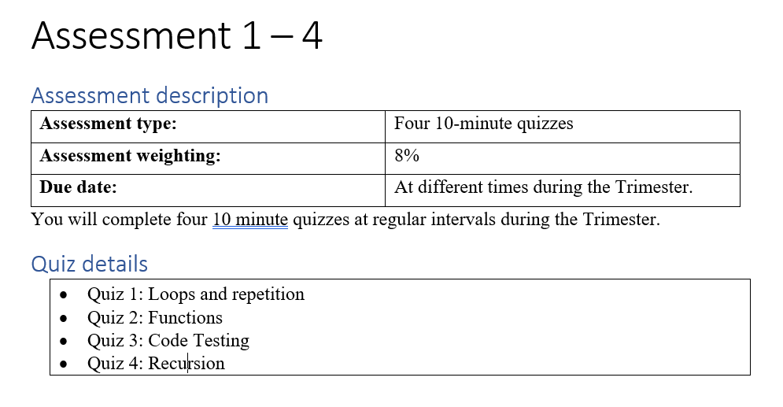

Figure 7 - Word document with a single Blackboard Card list

Cards can be added multiple times throughout a content interface document. They can also appear in any order. Whenever the Content Interface sees a *Blackboard Content* item in a Word document it will attempt to replace it with a card in Blackboard

For example, Figure 8 shows a modified version of the Word document from Figure 7. Another *Blackboard Card* list has been added at the bottom.

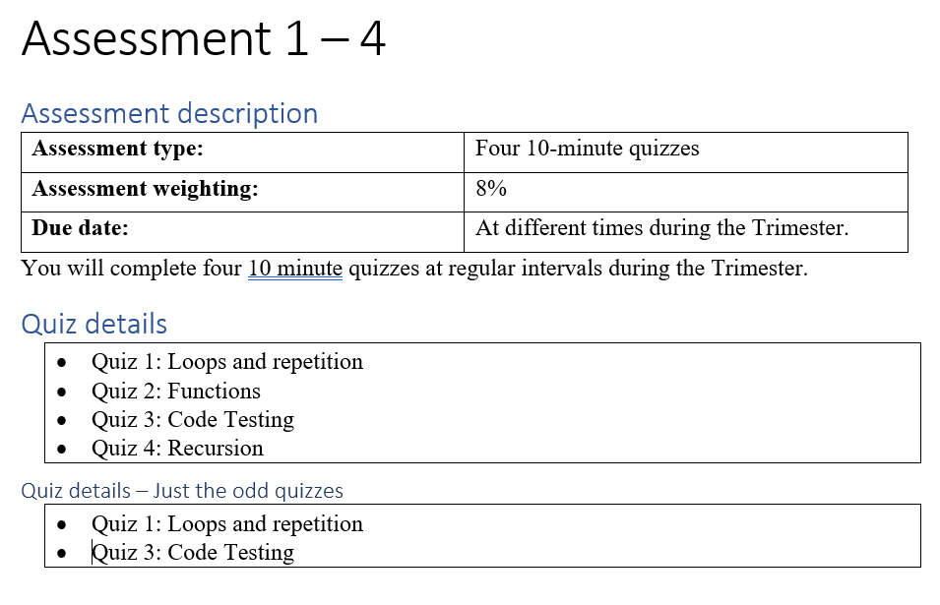

Figure 8 - Word document with two lists of cards

Figure 9 shows what this Word document looks like on the web in Blackboard. After the heading *Quiz details – Just the odd quizzes* you can see two more cards which are the same as the matching cards in the first list of cards.

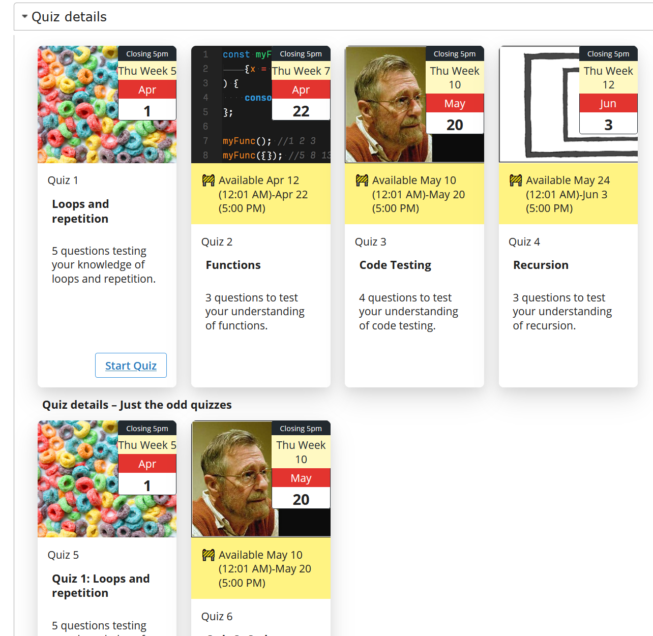

Figure 9 - The web version of the multiple card list document in Figure 8.

## Update the Blackboard page

The last step is to make sure the Word document is saved and update the matching Blackboard page to contain the new content.